opengl坐标系 z轴 离人越近越小

传入顶点数据需要使用VBO

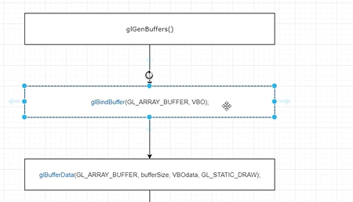

创建一个VBO 绑定顶点缓冲到VBO 顶点数据填充缓冲

之后再传入 shader 需要使用
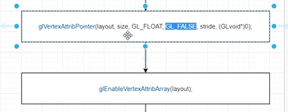

layout 对应shader中的layout

size 顶点坐标维度

GL_FLOAT 参数类型

GL_FALSE 是否归一化

stride 步长 两个顶点之间的距离 三个顶点就是 3X4个字节

最后一个是 顶点数据偏移量 顶点包含很多数据 位置信息 颜色信息 等

着色器可能存在多个 layout 一般最多16个 使用的时候 需要打开激活对应的单元 该方法就是这个功能 使用完之后 最好disable单元

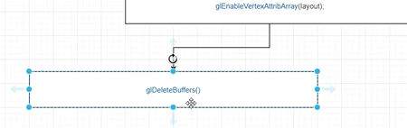

最后 回收分配的VBO buffer

//VBO
GLuint VBO;
glGenBuffers(1, &VBO);
glBindBuffer(GL_ARRAY_BUFFER, VBO);
glBufferData(GL_ARRAY_BUFFER, sizeof(vertext), vertext, GL_STATIC_DRAW);
//往layout传参数
glVertexAttribPointer(0, 3, GL_FLOAT, GL_FALSE, 3 * sizeof(float), (GLvoid*)0);
glEnableVertexAttribArray(0); //layout为0的单元打开

VAO

一个shader可能有很多个VBO 每个VBO对应一个顶点

VBO的集合是VAO 然后传给GPU

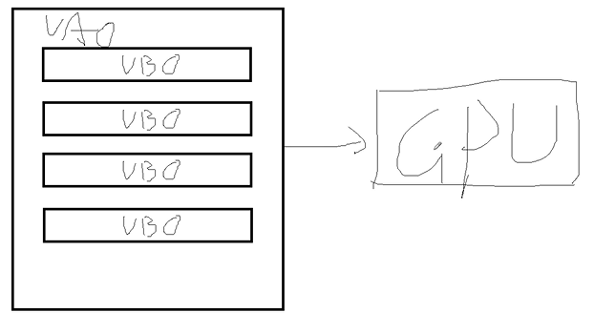

需要把VBO 放在VAO里面

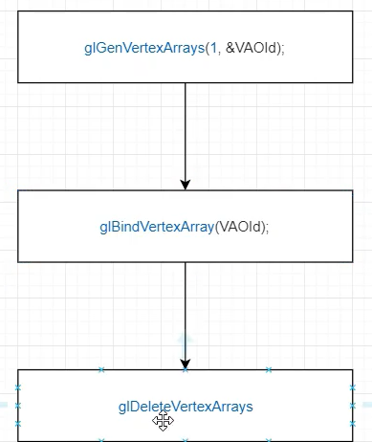

//VAO
GLuint VAOId = 0;
glGenVertexArrays(1, &VAOId);
glBindVertexArray(VAOId);

绘制
glClear(GL_COLOR_BUFFER_BIT);
program->UseProgram();
glBindVertexArray(VAOId);
glDrawArrays(GL_TRIANGLES, 0, 3);

封装VAO VBO

#pragma once
#include <glad/glad.h>
#include <GLFW/glfw3.h>
#include <vector>
enum ShaderType
{
VERTEX = 1,
FRAGMENT = 2
};
class Shader
{
public:
Shader(const char *shaderSource, ShaderType st);
~Shader();
GLint shaderId;

};
class Program
{
public:
Program(GLint vertexShader, GLint fragmentShader);
~Program();
int UseProgram();
private:
GLint programId = 0;
};
class VAO
{
public:
VAO();
~VAO();
int AddVertex3D(float *data, int vertexCount, int layout);
int BindVAO();
private:
GLuint vao=0;
std::vector<GLuint> vboList;
};

#include "Shader.h"
VAO::VAO()
{
glGenVertexArrays(1, &vao);
}
int VAO::AddVertex3D(float *data, int vertexCount, int layout)
{
glBindVertexArray(vao);
GLuint vbo = 0;
glGenBuffers(1, &vbo);
glBindBuffer(GL_ARRAY_BUFFER, vbo);
glBufferData(GL_ARRAY_BUFFER, vertexCount*3 * sizeof(float), data, GL_STATIC_DRAW);
//往layout传参数
glVertexAttribPointer(layout, 3, GL_FLOAT, GL_FALSE, 3 * sizeof(float), (GLvoid*)0);
glEnableVertexAttribArray(layout); //layout为0的单元打开
vboList.push_back(vbo);
glBindVertexArray(0);
return 0;
}
VAO::~VAO()
{
for (int i = 0;i < vboList.size();i++)
{
GLuint vbo = vboList[i];
glDeleteBuffers(1, &vbo);
}
vboList.clear();
if (vao != NULL)
{
glDeleteVertexArrays(1, &vao);
vao = NULL;
}
}
int VAO::BindVAO()
{
glBindVertexArray(vao);
return 0;
}

#include <glad/glad.h>
#include <GLFW/glfw3.h>
#include "Shader.h"
#include <iostream>
using namespace std;
#define STRINGIZE(x) #x
#define SHADER(shader) "" STRINGIZE(shader)
int main()
{
glfwInit();
glfwWindowHint(GLFW_CONTEXT_VERSION_MAJOR, 3);
glfwWindowHint(GLFW_CONTEXT_VERSION_MINOR, 3);
glfwWindowHint(GLFW_OPENGL_PROFILE, GLFW_OPENGL_CORE_PROFILE);
GLFWwindow* window= glfwCreateWindow(800,600,"OpenGL",nullptr,nullptr);
//opengl 运行模式单线程 要调用opengl api是在单一线程内进行
//多个线程同时调用不被允许
//绑定这个window与当前main函数的线程
glfwMakeContextCurrent(window);
//初始化glad
gladLoadGLLoader((GLADloadproc)glfwGetProcAddress);
//顶点数据
float vertex[] =
{
0.0f,1.0f,0.0f,
-1.0f,-1.0f,0.0f,
1.0f,-1.0f,0.0f
};
VAO *vao = new VAO();
vao->AddVertex3D(vertex, 3, 0);
//shader源码
const char * vertexShaderSource = SHADER(
#version 330\n
layout(location = 0) in vec3 pos; //输入
out vec3 outPos;
void main()
{
outPos = pos;
gl_Position = vec4(pos, 1.0); //输出
}
);
const char * fragmentShaderSource = SHADER(
#version 330\n
//输入来自顶点着色器 需要顶点着色器定义 out 变量
out vec4 color;
in vec3 outPos;
void main()
{
color = vec4(outPos, 1.0); //输出
}
);
Shader *vertexShader = new Shader(vertexShaderSource, ShaderType::VERTEX);
Shader *fragmentShader = new Shader(fragmentShaderSource, ShaderType::FRAGMENT);

Program * program = new Program(vertexShader->shaderId, fragmentShader->shaderId);
//绘制
while (!glfwWindowShouldClose(window)) //不关闭一直绘制
{
//
glClear(GL_COLOR_BUFFER_BIT);
program->UseProgram();
vao->BindVAO();
glDrawArrays(GL_TRIANGLES, 0, 3);
glfwSwapBuffers(window);
glfwPollEvents();
}
//释放
glfwTerminate();
delete vao;
delete vertexShader;
delete fragmentShader;
delete program;
return 0;
}

